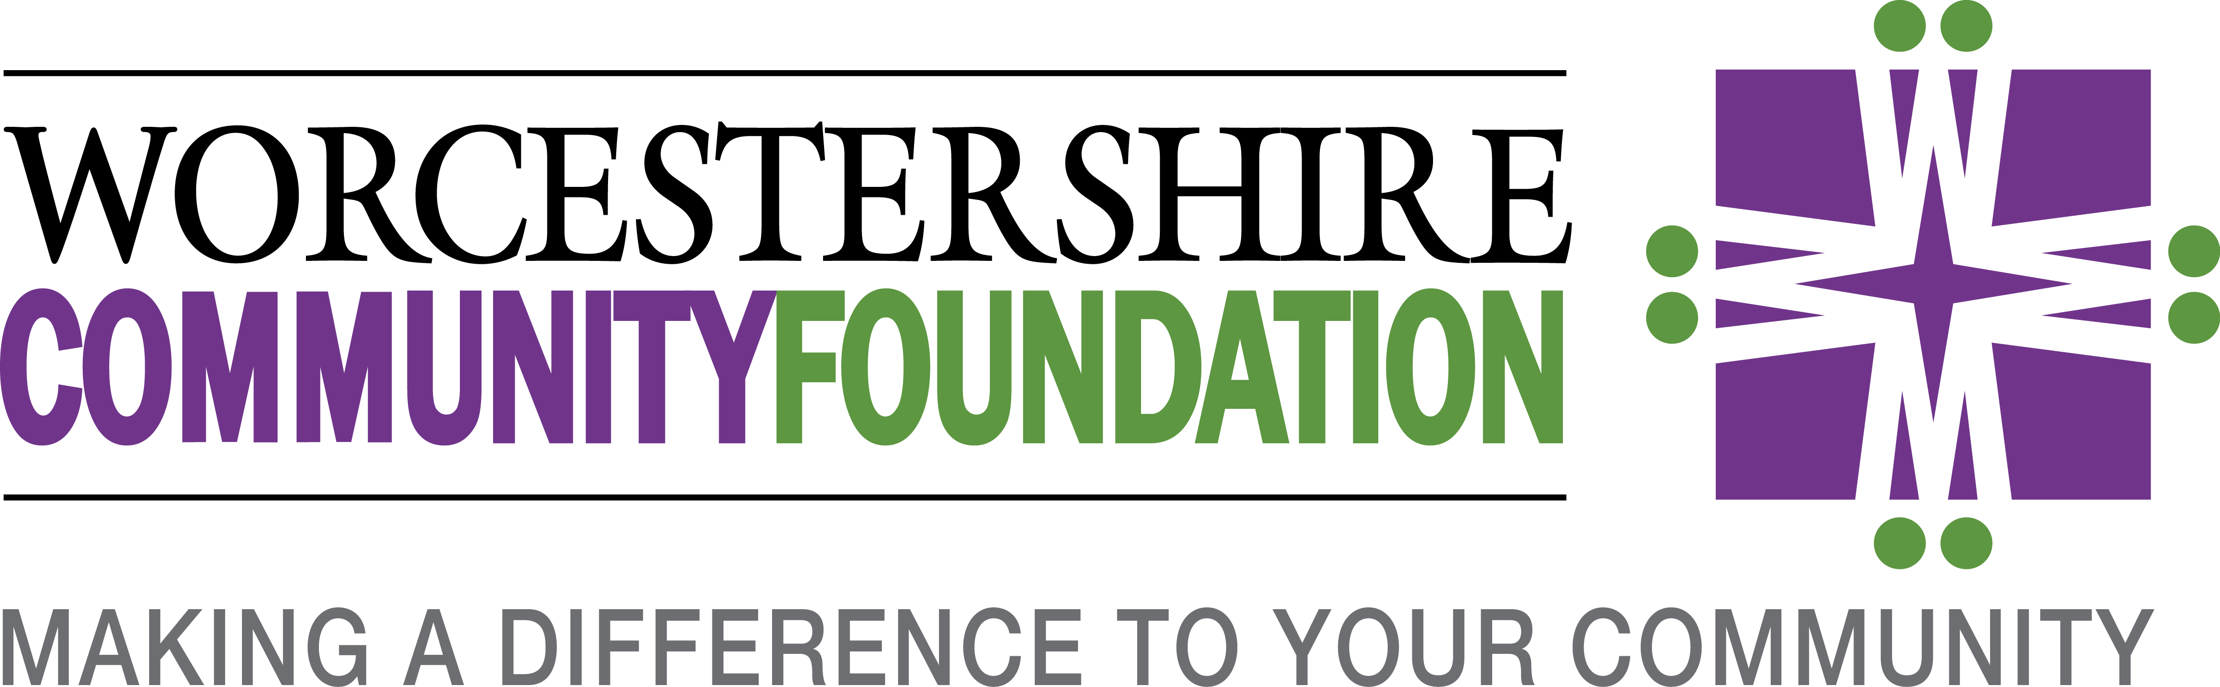

GIFT AID DECLARATION
Please treat my gift of £ as a Gift Aid donation.
I confirm I have paid or will pay an amount of Income Tax and/or Capital Gains Tax for the current tax year (6 April to 5 April) that is at least equal to the amount of tax that all the charities and Community Amateur Sports Clubs that I donate to will reclaim on my gifts for the current tax year. I understand that other taxes such as VAT and Council Tax do not qualify. I understand the charity will reclaim 25p of tax on every £1 that I have given.

I would like to gift aid this and all future donations:
Donor’s details
Title
First name
Surname
Full home address
Post Code
Date
Signature

Please notify Worcestershire Community Foundation if you:
• Want to cancel this declaration
• Change your name or home address
• No longer pay sufficient tax on your income and/or capital gains.
If you pay Income Tax at the higher or additional rate and want to receive the additional tax relief due to you, you must include all your Gift Aid donations on your Self Assessment tax return or ask HM Revenue and Customs to adjust your tax code.
NB: Please return this completed form by post to Worcestershire Community Foundation at the address below or email to Sharon.adams@worcscf.org.uk

Worcestershire Community Foundation is a Registered Charity No. 1102266
and a Company Limited by Guarantee. Incorporated in England No. 4809926

Registered Office: Kingsway House, 40 Foregate St, Worcester WR1 1EE
Lucy.wells@worcscf.org.uk

www.worcscf.org.uk

