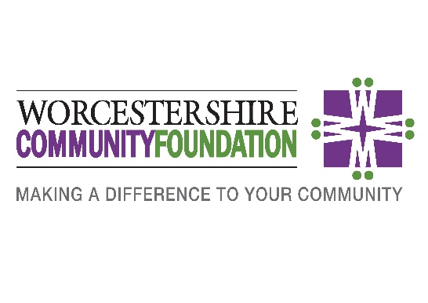

Working in Partnership with Professional Advisors

Helping you to exceed your clients’ expectations and offer practical solutions to fulfil their wishes

Established in 2003, Worcestershire Community Foundation (WCF) is an independent, grant making charity. As one of the central platforms for giving in the county, we are part of a national network of 47 community foundations across the UK who together form the fourth largest grant making body in the UK. Although we are all ‘place-based’ funders who operate independently, our overall shared aim is to improve the quality of life for local communities in our respective areas by facilitating local fundraising and giving.
Over the past 18 years, WCF has become a major funder to Worcestershire’s voluntary and community sector. From providing funding to support a handful of community groups in 2003, our total grant making during 2020/21 has exceeded £1 million; during this period we have supported hundreds of vital community projects reaching thousands of disadvantaged local people, addressing a wide range of challenges including mental health, homelessness, isolation and domestic abuse.

Quality accreditation and governance

WCF is Quality Accredited by our national membership body UK Community Foundations, with the QA5 award successfully achieved in 2021. Formally acknowledged and recognised by the Charity Commission for England and Wales, Quality Accreditation is a programme which endorses and encourages best practice by Community Foundations. Achieving Quality Accreditation demonstrates that a Community Foundation delivers to a standard and assures quality and accountability.
We view corporate governance as one of our most important responsibilities. Public confidence in the transparency and accountability of the work of charities has never been more important. Our promise to our donors is that, whatever the size and nature of their contribution, they can be sure it is going where it is needed and will do the most good.

Worcestershire’s needs

It is important to highlight the extent of deprivation which exists in Worcestershire. Our beautiful and much-visited county, which has so much to offer, still faces many challenges of disadvantage and social need, but much of it is hidden.
Popular notions of poverty and deprivation in Britain often assume they are problems confined to largescale inner city areas. The reality can be very different, with social need far more widespread than many are aware of.
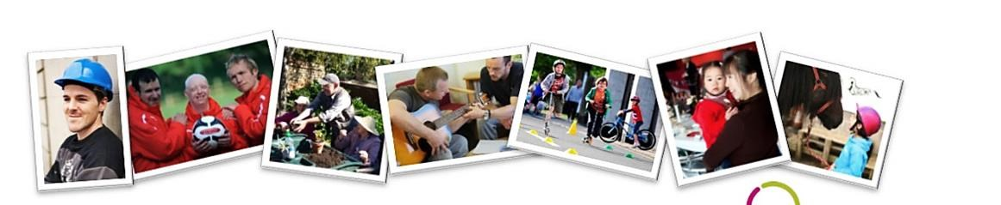

Over 80,000 people in Worcestershire live in income deprivation at the most minimal living standard provided by welfare benefits and well below the ‘poverty line’. In addition to this, the predominantly rural nature of the county amplifies some problems and creates additional ones such as personal isolation and transport issues.

The 2020 IMD* (Index of Multiple Deprivation) study shows that 18 local neighbourhoods reflecting 28,000 Worcestershire residents are ranked as some of the most deprived in England. This means almost 5% - or one in 20 people - in Worcestershire live within the top 10% of deprivation.

Redditch and the Wyre Forest experience some of the greatest deprivation, whilst in Worcester City more than one in 10 people live in the top 10%. Urban communities are most likely to experience deprivation, however rural deprivation is also endemic, especially in the Evesham and Wyre Forest areas. Many people currently live in fuel poverty, with this figure set to soar during Winter 2021 with the current energy crisis, and mental health/wellbeing challenges across society are rising swiftly.

Post-Covid, Worcestershire faces growing challenges of disadvantage and social need.
The impact of the Pandemic has substantially exacerbated needs through increased social isolation, worsening health issues- including mental health- and growing poverty.

WCF was established to help address these issues and other emerging needs; our unique stance is both proactive and reactive, so that we can be flexible in our grant-making approach. Through our research, connections and understanding of local issues, our purpose is to enable donors to undertake informed and targeted grant making to support the causes they care about and ultimately help the lives of the communities in the county they live in.

What can we offer you?

As an impartial charitable hub, we can offer simple and effective solutions for families, companies and trusts to make a lasting difference in our communities. We offer expert philanthropic guidance, comprehensive support and professional administration of charitable giving.

Our offer includes:
- Advice and guidance to create a charitable giving strategy for families
- Unrivalled knowledge of local need and the local voluntary sector
- Due diligence on charities to ensure donations are well spent
- Grant making including inviting and assessing applications for funding
- Monitoring & evaluation of the impact of giving
- Investment management of charitable funds

In short, we help you support your clients to do good in more effective and user-friendly ways.

As individuals’ understanding of social needs and their role in supporting their own communities increases, there is growing interest to learn more about philanthropy and charitable giving and the options available to them. Good advice in this area is important.

Working together we can provide a fully inclusive offering to help you meet your clients’ charitable goals and exceed their expectations in terms of the range of options available to them. Whether you are a lawyer, accountant, financial planner, investment advisor or have a specific interest in the technical aspects of planned giving, by combining your expertise with our experience in advising on philanthropy, together, we can ensure that your clients’ charitable giving meets the causes they wish to support.

We provide a range of options for private clients who are interested in:
- Leaving a legacy or gift in their will
- Transferring the burden of running a charitable trust
- Setting up a personal ‘named’ fund
- Setting up an ‘In Memory’ fund

Our Fund Options

When setting up a fund, donors can choose from a number of options, depending on their charitable aims. WCF can provide advice and guidance on which approach has the best fit for the individual client.

Flow-through fund:
The donor makes an annual donation to a flow-through fund, which is awarded as grants each year to provide immediate support to the local community. The donor can select the causes they wish to support.

Endowment fund:
The donor usually gives a lump sum which is held in perpetuity and invested. The investment income is then distributed annually as grants to the local community. Endowment funds are designed to create a growing and sustainable source of funds into the future.
The donor can select the causes they wish to support add to their funds over time.

Combined fund:
The donor can combine the benefits of both endowment and flow-through funds to enable them to make more immediate grants as well as growing grant-making from their endowment over time.

Our Range of Services

Corporate Donors
We offer similar support to corporate donors (including businesses of all sizes, solicitors, accountants and land agents etc.) who have an interest in the local community and are interested in putting their corporate social responsibility (CSR) into practice.

Charitable Trusts
We can also take on existing charitable trusts that are ineffective on account of difficulties in identifying beneficiaries or attracting new trustees. We provide a range of options from assisting with grant making to taking over legal responsibilities for the trust completely, yet with clients retaining an interest.

Benefit to your Clients
Community Foundations are an ideal vehicle for philanthropists to put some structure around their giving in a tax efficient way. It offers a flexible alternative to creating conventional charitable trusts or a foundation, which can prove complicated and costly to set up and administer. The administrative and governance burden on trustees of running a conventional charitable trust is ever increasing which, understandably, can be off-putting to many clients.

We offer a practical solution, making charitable giving to local causes stress free, easy and enjoyable for clients, whether the amounts they set aside are large or relatively modest.

In line with the Charity Commission’s advice, our purpose is to ensure that donors are aware of the full range of options available.

Whether your client is looking to establish a personal fund through a lifetime donation or a legacy in their will, or wishes to reduce the administrative burden of an existing trust, we can work with you and your client to find the best solution.

By working with Worcestershire Community Foundation, you and your clients can benefit in a number of ways:

- We are local - your clients’ funds will be used to support the local community in which they live and work. They can personally select the causes they wish to support, visit projects and see for themselves the positive impact that their charitable giving achieves.

- We are impartial - you may be reluctant to recommend specific charities to your clients for reasons of impartiality. We do not favour any particular cause or theme.

- We are flexible - with a named family fund (which operates in a similar way to a charitable trust), your clients choose the causes they wish to support. Grants can be made to charitable causes and not just registered charities (for example, improving health and wellbeing or access to learning and improving skills and employability). Clients can change their focus at any time which enables them to respond quickly to emerging social need. Clients can be involved as little or as much as they like.

- We are quick and efficient - we can set up a named fund after one meeting rather than waiting several months or longer to register as a charitable trust.

- We make giving easy - we promote the fund and invite applications from community groups to fund their project, review grant applications, provide summaries of the projects, check validity and that the charity’s or community group’s project falls within the Foundation’s charitable objectives. We arrange for the

donations to be made from the fund and undertake monitoring to ensure the money has been spent on the project and to measure the impact it has made.

- We are knowledgeable - we have unparalleled knowledge of local community need and can match your clients’ interests to specific projects, causes and initiatives; we have wide experience in giving out funds to legitimate and effective community-focused organisations, so you know that your gift will make a difference.

- Your clients decide which projects to support - we encourage donors to have full involvement in decision-making including which community projects to support and the level of funding. Ultimately, responsibility lies with the trustees of WCF and grants can only be made following their ratification.

- We help clients give tax-effectively - as a registered charity we are an ideal vehicle for all methods of tax-effective giving, offering significant tax benefits for your clients including relief from income tax, capital gains tax, inheritance tax and corporation tax. We can also accept gifts in cash, shares, land, property or other assets which can also be made tax efficiently.

- We are here to stay - if a client leaves a legacy in a will today, it is possible that the charity or cause they wanted to fund is either no longer in existence or in need of assistance by the time their will comes into effect. With a named fund, our trustees have discretion over the distribution of gifts left to them. We can ensure that the original intentions of your client are carried out without having to approach the Charity Commission for a variance of the original deeds of a trust or intentions in a will.

- We are transparent - we ask for a contribution towards our administration costs for managing a fund which varies depending on the size and type of fund and we agree this, up front, with donors. We operate with a very low overall administrative overhead, which means that more money can go out in grants to the community.

- We carry the financial and legal responsibility - setting up a personal charitable trust can be time consuming and costly to establish and administer. The onus on trustees is increasing – to invest and monitor the investment of funds, to ensure regulations are followed in grant making, to meet the stringent needs of accounting requirements under SORP as well as the independent scrutiny of the accounts. With a named fund at WCF, all these responsibilities lie with our trustees.

- Above all, our offering is personalised and very flexible so we will be able to find a solution that meets, and maybe even exceeds, your clients’ needs and expectations, which we know will strengthen and deepen your relationship with them.

To have an informal chat about how we can work in partnership with you please contact Lucy Wells (Development Director) at lucy.wcf@comfirst.org.uk/ 07909 111812.

Creating a named fund versus setting up a charitable trust- Pros & Cons
Area covered | Setting up your own charitable trust | Creating a named fund with WCF
Set-up process | Must register as Charity, apply to Charities Commission (CC) & appoint a board of trustees. This is a long process of up to 12 months. | A simple process takes just a few days and involves a WCF fund agreement so everything is transparent
Associated costs | Initial set-up costs of around £1000 with ongoing audit fees | Endowment funds: Example- 5% of initial donation & 1.25% of endowment capital p.a.  Flow-through funds: Example: 10-15% of annual donation/funds raised
Reporting & compliance | Trustees must maintain all financial records, prepare accounts & submit to CC | WCF will take care of reporting to the CC, including the annual report and accounts
Spending funds strategically | Trustees are responsible for the grant making process inc. administration, due diligence & grant monitoring. Many new trusts received hundreds of unsolicited applications. | Our team will promote your fund, assess applications, monitor grants & report back to donors regularly. The donor can be involved as much as they like and have influence over the fund, or they can leave it to us.
Philanthropy advice & local knowledge | Trustees are responsible for their own giving strategy which may require the support of private consultants | We offer support to help the donor create their giving strategy and help them maximise the impact of their fund in selected areas or themes
Donor influence & control | The donor appoints a board of trustees to control all aspects of grant making & investment | Trustees of WCF take on legal & fiscal responsibility for the donor’s fund whilst the donor chooses grants to organisations vetted by WCF
Flexibility for innovation | Donations are typically restricted to registered charities | WCF can make donations to both registered/non-registered community groups in Worcestershire & beyond. We can also support the donor & advisor to explore innovative options
Strong financial performance | Trustees will need to undertake their own investment strategy & invest funds as a single organisation | Fundholders can benefit from strong investment performance through WCF’s selected investment companies that are regularly reviewed
Recognition & publicity | Donors will need to liaise directly with charities and/or media to publicise their support if required | WCF can promote the fund and organise marketing activities as required. Equally we can maintain complete donor confidentiality if desired
Engaging with charities | Donors will need to liaise directly with charities to arrange visits to projects or volunteering | WCF can arrange project visits and volunteering opportunities as required.

